LDR-BASED HOME SECURITY LIGHTING SYSTEM

Aim
To design and construct a light-sensing home security system using a Light Dependent Resistor (LDR), which automatically switches on an LED (representing a security/porch light) when the surrounding light level drops, simulating an automatic security light that activates after dark.

Components Required
S.No | Component | Qty | Specification
1 | LDR (Light Dependent Resistor) | 1 | Standard 5mm LDR
2 | Sensor / driver module | 1 | Onboard comparator with threshold potentiometer
3 | LED (indicator/security light) | 1 | Green, 5mm
4 | Breadboard | 1 | Standard solderless breadboard
5 | Battery | 1 | 9V / battery pack
6 | Jumper wires | Several | Male-male
7 | Model house (demo enclosure) | 1 | Cardboard and chart paper

Procedure
- Place the breadboard on a flat surface and mount the sensor/driver module on it.
- Connect the LDR to the input terminals of the sensor module.
- Connect the LED to the output terminal of the sensor module, observing correct polarity (anode to positive).
- Connect the battery's positive and negative terminals to the power rails of the breadboard to supply the circuit.
- Adjust the onboard potentiometer on the sensor module to set the light-threshold sensitivity.
- Mount the assembled circuit inside the model house, with the LDR positioned to sense the interior/ambient light and the LED positioned as the security light.
- Test the circuit by exposing the LDR to bright light and then covering it or dimming the surroundings, and note the LED's response.

Working
The LDR is a light-sensitive resistor whose resistance decreases as light intensity increases and rises sharply in darkness. It forms part of a voltage-divider network on the sensor module, whose midpoint voltage is compared against a preset threshold by an onboard comparator. In bright conditions, the LDR's resistance is low, holding the comparator output — and hence the LED — OFF. When the light level falls, the LDR's resistance rises, the divider voltage crosses the threshold, and the comparator switches its output, turning the LED ON. This automatic ON/OFF behaviour is used to simulate a security light that activates at dusk or when an intruder blocks the ambient light source, making an unoccupied home appear active and deterring intrusion.

Observation
S.No | Ambient Condition | LDR Resistance | LED Status
1 | Bright light (daytime) | Low | OFF
2 | Dim light (dusk) | Medium | OFF / borderline
3 | Darkness (night / covered) | High | ON

Result / Image
The LDR-based home security circuit was successfully constructed and tested. The LED turned ON when the LDR was subjected to low light/darkness and remained OFF under bright light, confirming correct automatic operation of the light-sensing security system.
Circuit diagram :
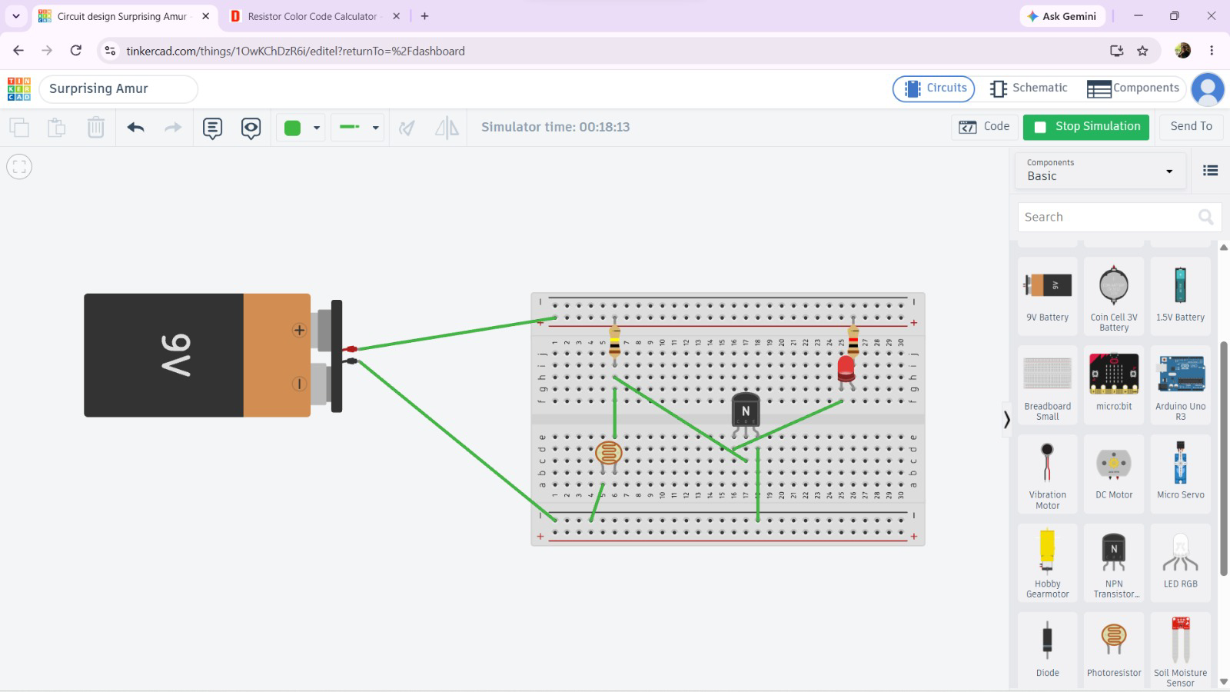
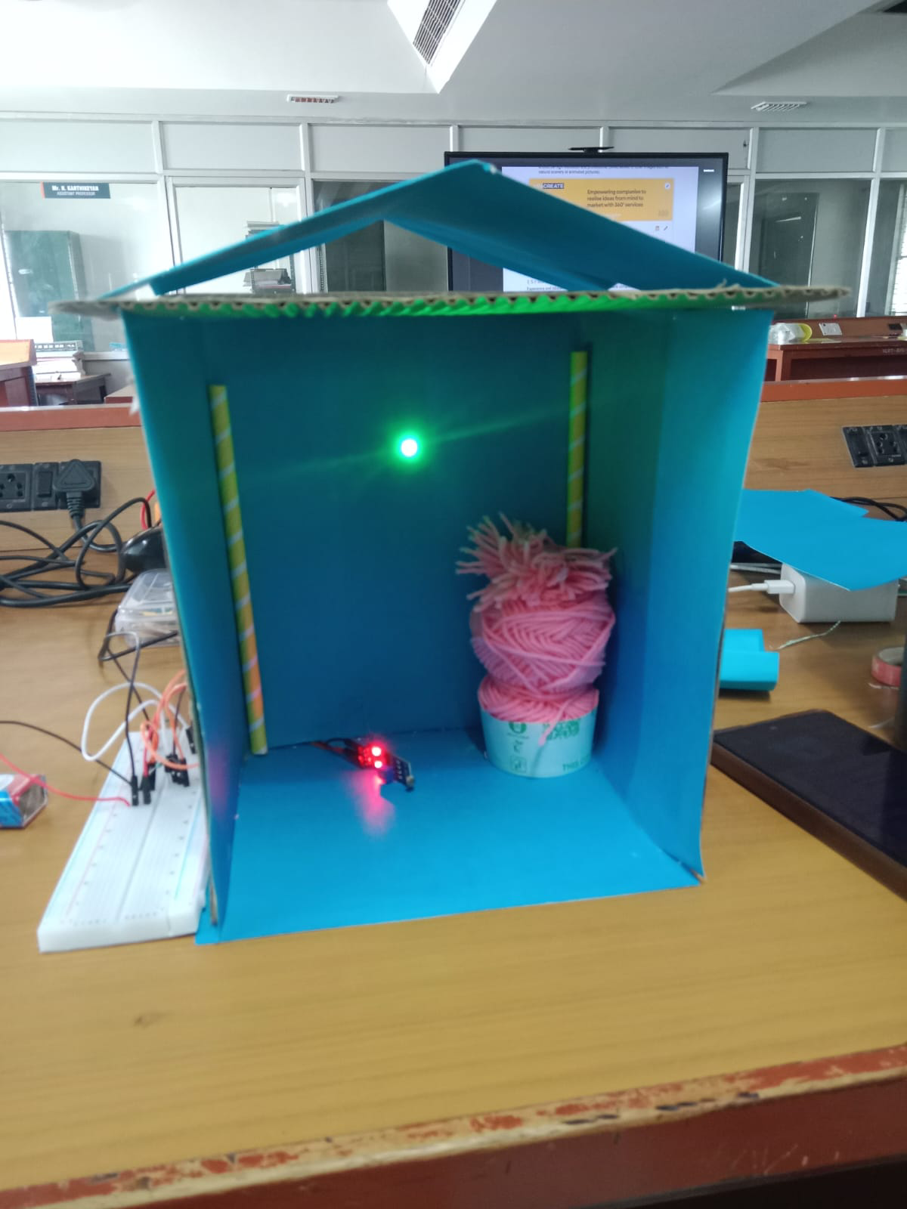
Fig: Working prototype of the LDR-based home security lighting system

